JAVA

java is platform independent programming language because it generates .class file which contains byte code of the program
but like c lang which generates .obj file which is machine code

java engines
jdk => java development kit
jvm => java virtual machine
jit => just in time compiler
jre => java runtime environment
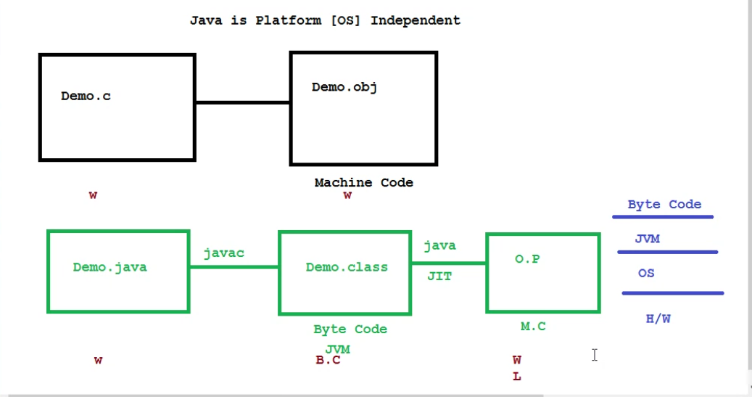

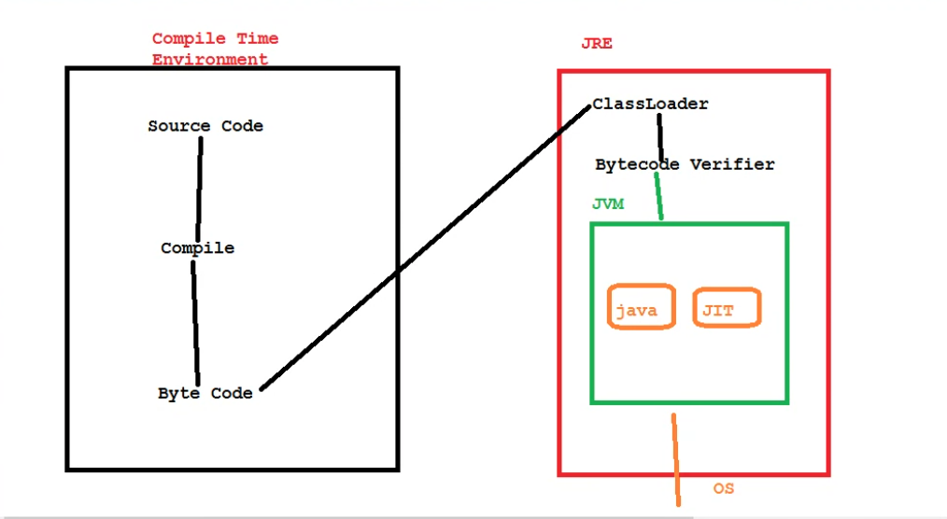

** in java static method can be runned without any object declaration **

String is a predefined class from java.lang package and java.lang is a default package which is not imported
In java main class args[] is just a name which can be used as any name and args[] is used to store collection of objects

System.out.println(“”);
Out is a predefined method
Print is predefined method in io package

Java Data Types
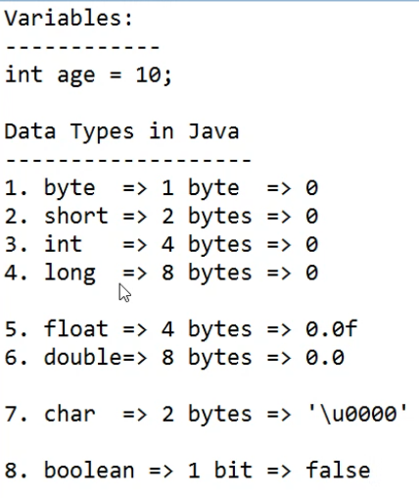
There are 8 types of primitive data types

New
New is a keyword which is used to allocate memory to a object in runtime
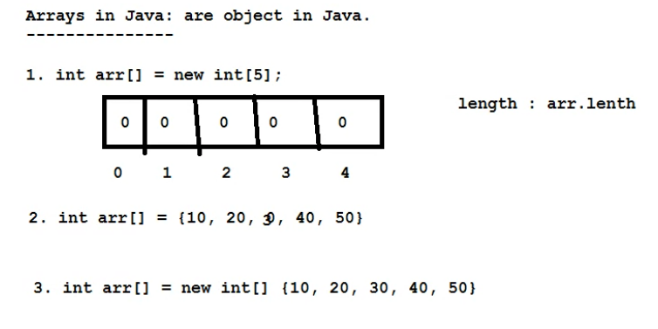
1) Fibonacci Series in Java
2) Prime Number Program in Java
3) Palindrome Program in Java
4) Factorial Program in Java
5) Armstrong Number in Java
6) How to Generate Random Number in Java
7) How to Print Pattern in Java
8) How to Compare Two Objects in Java
9) How to Create Object in Java
10) How to Print ASCII Value in Java

